**What is confidential information?**

Confidential information means private information you would only want to share if there is a really good reason, with people you trust. Confidential information could be things like your criminal record or details of things that have happened to you in the past.

Private information means things that other people cannot know until you tell them – like your National Insurance Number. You have probably shared this information with a lot of places already, like your bank or your employer.

Personal information means facts about you that someone could guess by looking at you – like your height or age.



**What does confidentiality mean?**

Confidentiality is not the same as secrecy

We cannot promise total secrecy to anyone because we need to help and protect our residents and our staff and we must also keep to the law.

We will treat all private and confidential information from you and about you in a respectful way to protect your rights and provide effective support; however we cannot

guarantee absolute confidentiality in every circumstance.

Confidentiality means that your private and personal information will be kept within CHYP – staff may need to discuss this information with other members of staff, but only if this is

both appropriate and necessary – but staff will not disclose or share your information outside of CHYP if you haven’t already agreed that we can do this; unless **special circumstances** apply.

**Is that why you have that *Consent to Contact Your Referees* part in the application form?**

Yes! We ask for your consent so that we can speak to your referees about your current circumstances and your housing situation – and they can speak to us!

We might also ask for your consent to share information with other organisation who could help you – like the Housing Department or Social Services.

**What about those *Special Circumstances*?**

CHYP might need to share your private or confidential information with other professionals or organisations if any of the following apply:-

1. If we believe that you may be at risk of serious harm from someone, or may be about to cause serious harm to someone else.
2. If we believe that someone under the age of 18 years old is at risk of abuse. This could be because you have told us something that happened to you and it is possible that the abuser is in contact with children or other young people.

**Special Circumstances** (contd.)

1. If we have to do this by law or are required to do this by a court. This does not mean that we will contact ther Police if you tell us that you have stolen something from a shop or used illegal drugs – it only applies to very serious things like acts of terrorism!

**What if I am under 18 years old?**

If you are 16 or 17 years old, the rules mean you have the same rights when it comes to information sharing or data protection except where child protection issues are involved; because the law says that any disclosures must be reported.

**What about my file?**

We will make sure that all your information is kept safely and securely and is only seen by those people who have the right to know and the need to know.

**What about Data Protection?**

Under the Data Protection Act, we need your consent to hold and process personal information about you. This is why we asked you to give your permission for us to do this when you filled in your application form, and we will ask you again when you have moved in.

**What happens after I leave?**

You have the same rights to confidentiality and Data Protection after you leave CHYP. We must keep your file and all other records about you secure in the same way as we did before. We have to keep all records for at least 5 years after people leave.

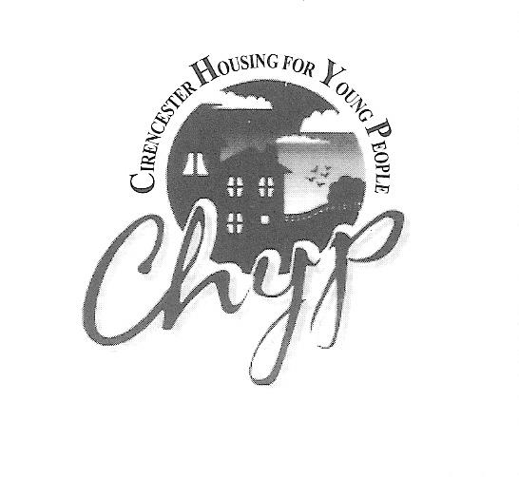

You can contact us at:

CHYP

29-31 Querns Lane, Cirencester,

Glos. GL7 1RL

(01285) 651227

[chyp@btinternet.com](mailto:chyp@btinternet.com)

We are happy to produce this information in another language or format on request.