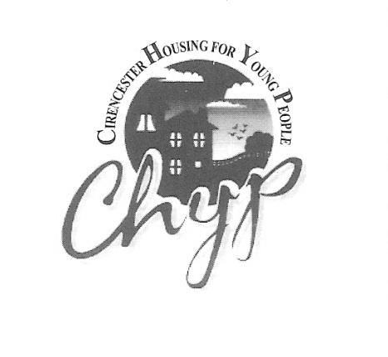

Application for accommodation at CHYP

Your details
Your name

Your mobile number

When is the best time to call you?
Is there an address where we can write to you?

Your Date of Birth |  |  |  | Your age
Do you identify as.? | Female |  | Male |  | Trans |  | Other
Do you have a physical, medical or mental health condition which has a substantial and long term effect on your day-to-day life? No Yes if yes, please tick boxes below:
ADD / ADHD Autism/Aspergers Learning difficulty Mental health e.g. anxiety or eating disorder
Medical e.g. diabetes/epilepsy Physical Vision, hearing or speech impaired
Women only, are you pregnant? No Yes

Do you have any other special needs we might need to know about so that we can help you?
No Yes
Are you a..?
British Citizen Citizen of the UK and colonies EU / EEA Citizen* Other nationality
* The EU/EEA countries are: Austria, Belgium, Bulgaria, Croatia, Republic of Cyprus, Czech Republic, Denmark, Estonia, Finland, France, Germany, Greece, Hungary, Iceland, Ireland, Italy, Latvia, Liechtenstein, Lithuania, Luxembourg, Malta, Netherlands, Norway, Poland, Portugal, Romania, Slovakia, Slovenia, Spain and Sweden
Do you have a passport or a full birth certificate (which shows your parent[s] names) or a driving licence?
No Yes
Do you know your National Insurance number?
No Yes
Do you have a bank or building society account which is in your own name?
No Yes

Reason for your application
In one or two sentences, can you explain why you are applying for accommodation at CHYP?

More about you
Do you have any cautions or police warnings? | No Yes
Have you ever been found guilty by a magistrate’s court or a crown court? | No Yes
Are you on bail at the moment or do you have any court dates coming up? | No Yes
Has any action ever been taken against you by the Police, a local authority or a housing association for anti-social behaviour? | No Yes
Are you currently working with Probation or Youth Offending? | No Yes

Housing
Have you ever had a bedsit, lodgings or a flat of your own? | No Yes
Have you ever been evicted from, or asked to leave any previous accommodation? | No Yes
Do you have any rent arrears from previous accommodation? | No Yes
Have you ever been fostered or ‘looked after’ by the local authority? | No Yes
How long have you lived in the Cotswolds?

Do you have any close relatives living this area? | No Yes
If you haven’t lived in this area before and you don’t have any relatives living here, what is your local connection?

Learning, earning and leisure
Are you..?
working? at college? unemployed? sick/disabled?
How do you spend your time when you’re not at work or college?

Money
What is your income at the moment?

Have you ever claimed ‘Universal Credit’? | No Yes
Have you ever claimed ‘Housing Benefit’? | No Yes
If you’re not working at the moment and you’re not claiming benefits, what are you living on?

Do you have any debts or payment commitments e.g. phone contract, overdraft, payday loans, court fines etc. | No Yes
Have you ever had any issues with betting, gaming or gambling? | No Yes

Health and emotional wellbeing
Do you have any physical health problems or medical conditions we might need to know about that you haven’t already mentioned? | No Yes
Have you ever experienced anxiety, depression or some other mental health issue? | No Yes
Do you think you have ever had an eating disorder or issues with food? | No Yes
Have you ever received hospital treatment for your mental health? | No Yes
Are you taking any regular medication? | No Yes

Drugs and alcohol
How often do you drink alcohol?
Never Once or twice a year Once a month Once a week Several times a week Most days
Do you think you have ever had any issues with alcohol?
No Yes
How often do you use non-prescription drugs, solvents or ‘legal highs’?
Never Once or twice a year Once a month Once a week Several times a week Most days
Do you think you have ever had any issues with drugs, solvents or ‘legal highs’?
No Yes
Have you ever used non-prescription drugs, solvents or ‘legal highs’ whilst you’ve been drinking?
No Yes

Support networks
Please tick if you receive help or support on a regular basis from any of these services
Doctor Social Worker Children & Young People’s Service Youth Support Team
Youth Justice or Probation Drug or alcohol services Hospital consultant
Counsellor Mental health worker Floating support worker
Who are the important people in your life?

Do you know anyone who is living at CHYP at the moment or who has lived here in the past?
No Yes

Safeguarding
Have you ever deliberately harmed yourself or taken too much medication?
No Yes
Have you ever lost control and hurt someone or damaged something?
No Yes
Have you ever experienced violence, abuse or exploitation by other people?
No Yes
Have you ever experienced bullying, harassment or discrimination?
No Yes
Do you feel at risk of violence, abuse or exploitation by other people at the moment?
No Yes
Is there anyone who you should not have contact with?
No Yes
Is there anything else we might need to know about so we can help you to stay safe?
No Yes

Your declaration
- I give my consent for CHYP to keep and process the personal information contained in this application form in accordance with the Data Protection Act (1998)
- I confirm that the information I have given is true and correct to the best of my knowledge
- I understand that giving false or misleading information could lead to the withdrawal of services, which means I could be asked to leave CHYP if I have already moved in
Signed |  | Date

Continue to the next page

What happens next
- Fill in details of your referees below – we will need to speak to at least two people who can tell us a bit about you, your circumstances or your housing situation.
- Return the whole form to us at the address or email shown below.
- We will contact you to arrange a date for you to come in for an informal assessment interview.
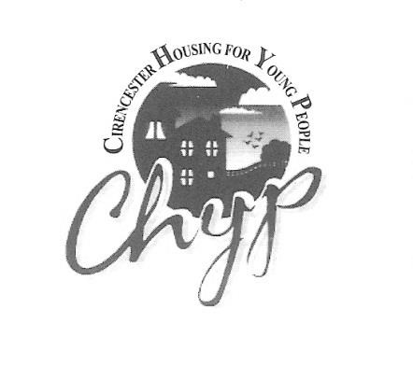
CHYP – Cirencester Housing for Young People
29-31 Querns Lane
Cirencester
Glos.
GL7 1RL
(01285) 651227
chyp@btinternet.com

Consent to contact your referees
As part of your application for supported accommodation at CHYP, we will need to speak to at least two different people who can confirm the information on your application form, or tell us about your current circumstances or your housing situation.

Ideally, your references should be people who have known you, or worked with you, for a little while and have an understanding of your circumstances and support needs.

If you are 16 or 17 years old and have recently left your family home, but are not being looked after by the local authority, we will need to speak to your parent(s) or guardian to confirm that you are ‘estranged’ from them and are unable to live with them, unless doing this would put you at risk of harm. If you feel that this is the case, please tell us.

1st referees name

Their relationship to you

Their phone number

2nd referees name

Their relationship to you

Their phone number

3rd referees name

Their relationship to you

Their phone number

Please sign below to show that:-
- you give your consent for us to contact the people/organisations you have named above
- you give your consent for those people/organisations named above to speak to us, and provide us with information about your suitability for living in shared accommodation, your housing situation and your support needs
Signed: |  | Date:
Print name:

